Abstract
Regions defined by semi-arid climates face a compounding challenge: limited water availability, growing energy demand, and mounting pressure on agricultural land. No single technology solves all three at once. This paper examines whether coupling two mature but separately studied technologies — agrivoltaic (AV) systems and anaerobic digestion (AD) — can create a circular, land-efficient response to this challenge. We develop and apply an integrated optimization model to three climatically distinct semi-arid sites: Konya, Turkey (cold semi-arid, BSk), Almería, Spain (hot semi-arid, BSh), and Ouagadougou, Burkina Faso (tropical semi-arid, BSh). For each site, hourly Typical Meteorological Year data from the PVGIS-SARAH2 database drive a coupled simulation that simultaneously models bifacial photovoltaic power generation, tomato crop yield under partial shading, evapotranspiration reduction, anaerobic biogas production from crop residues, and digester thermal management. Six design variables — panel tilt, row spacing, module height, digester volume, hydraulic retention time, and the fraction of PV electricity allocated to digester heating — are jointly optimized using differential evolution to maximize a novel three-component extended Land Equivalent Ratio (eLER). The eLER generalizes the classical two-component LER to include biogas as a third land-use output, enabling direct, dimensionally consistent comparison across all system outputs. Optimized eLER values reach 1.717 at Konya, 1.669 at Almería, and 1.674 at Ouagadougou. At all three sites, the biogas component alone contributes a land-use increment of approximately 1.0, a value equal to or exceeding the combined crop and PV contribution (LER_2C = 0.67–0.72). This finding — that waste valorization through AD generates land-use efficiency comparable to the agrivoltaic benefit itself — is the central novel result of the study. The temperature-corrected biochemical methane potential varies from 207 NmL CH₄/gVS at Konya to 290 NmL CH₄/gVS at Ouagadougou, quantifying how continental cold winters suppress biogas yield. Energy self-sufficiency ratios of 37–207 confirm that PV generation is abundant enough to fully supply digester thermal demand at all three sites, demonstrating that the AD subsystem does not compete with grid export revenue under optimal design. These results establish that integrated APV-AD systems offer a robust, multi-output strategy for sustainable intensification in semi-arid agroecosystems, and provide the first systematic multi-climate quantification of the three-way food-energy-water trade-off using a unified performance metric.
Keywords: agrivoltaics, anaerobic digestion, water-energy-food nexus, Land Equivalent Ratio, semi-arid, differential evolution, Konya, Almería, Ouagadougou.

1. Introduction
By 2050, global food production must increase by roughly 50% to feed a population approaching ten billion, while freshwater withdrawals for agriculture — already consuming 70% of the world's accessible freshwater — are expected to intensify further (FAO, 2017) (FAO, 2017; Scanlon et al., 2023). In semi-arid regions, this pressure arrives on top of a pre-existing deficit: potential evapotranspiration already exceeds precipitation for most of the year, making every millimeter of saved irrigation water economically and ecologically significant. Meanwhile, the energy sector faces its own transition, with solar photovoltaics emerging as the lowest-cost source of new electricity generation in many of these same regions (Renewable Power Generation Costs in 2022, 2022). The tension between solar deployment and agricultural land is real and growing; large ground-mount installations can displace food production from productive soils, replacing one resource challenge with another (Dinesh & Pearce, 2016).
Agrivoltaics — the co-location of photovoltaic modules and crops on the same land parcel — was conceived precisely to dissolve this tension (Dupraz et al., 2011; Goetzberger & Zastrow, 1982). The premise is elegant: panels elevated above crops generate electricity while the partial shade they cast reduces heat stress, curbs soil moisture evaporation, and can actually raise crop yields for species adapted to moderate shade. A growing body of field evidence confirms this dual benefit across crop species, climates, and panel configurations (Barron-Gafford et al., 2019; Semeraro et al., 2024). The Land Equivalent Ratio, a metric developed decades earlier for intercropping systems (Mead & Willey, 1980), has been repurposed to quantify the land productivity gain: published two-component LER values for agrivoltaic systems range from 1.2 to 1.94, meaning the combined system outperforms two separate monocultures by 20 to 94% on the same land (Mazzeo et al., 2025; Riaz et al., 2022).
What agrivoltaics alone does not address is what happens after harvest. A one-hectare tomato farm generates roughly 48 tons of fresh residues each season — stems, leaves, roots, and culled fruit — most of which are either burned, landfilled, or composted at low efficiency. Anaerobic digestion (AD) converts this organic stream into two valuable outputs: biogas, a storable and dispatchable energy carrier, and digestate, a nutrient-rich biofertilizer that can replace synthetic inputs (Möller & Müller, 2012). The natural pairing between an agrivoltaic system and an on-farm digester is compelling: the PV electricity can stabilize digester temperature, the digester processes the crop residues that the agrivoltaic field generates, and the digestate returns macronutrients to the soil beneath the panels. The circle closes.
Despite the logical complementarity of these two technologies, research has so far treated them in isolation. Agrivoltaic optimization studies focus on panel geometry, crop PAR, and energy yield, but ignore the residue stream entirely (Riaz et al., 2022; Zainali et al., 2023). Anaerobic digestion studies model heating energy supply — including from PV — but treat the associated crop system only as a passive feedstock source, without jointly optimizing the two (Pal & Ilango, 2024; Temiz et al., n.d.). Most critically, no study has proposed a unified performance metric that captures food, electricity, and biogas outputs on the same land-use basis, making cross-system comparisons impossible.
This paper addresses that gap directly. We present an integrated optimization framework that simultaneously designs the agrivoltaic architecture and the anaerobic digestion subsystem for a given climate and crop, and we propose an extended Land Equivalent Ratio (eLER) that adds biogas as a third component to enable consistent, multi-output land productivity assessment. The framework is applied to three semi-arid sites spanning three continents and two climate subtypes, providing the first systematic multi-climate comparison of integrated APV-AD performance.
The specific contributions of this work are as follows. First, we introduce a six-variable differential evolution optimizer that jointly searches the APV design space (tilt angle, row spacing, module height) and the AD design space (digester volume, hydraulic retention time, PV heating fraction), with both PV and AD thermal models driven by the same hourly PVGIS-SARAH2 climate data. Second, we define and implement the eLER metric, which extends the classical two-component LER to include biogas, and demonstrate that this third component adds a land-use increment of approximately 1.0 at all three sites — as large as the entire two-component agrivoltaic benefit. Third, we provide the first quantification of how continental cold winters suppress biogas yield through Arrhenius temperature correction of the biochemical methane potential, and show that even at the coldest site (Konya, $T_{min}= -18°C$) (JRC Photovoltaic Geographical Information System (PVGIS) - European Commission, n.d.), PV generation is abundant enough to fully cover digester thermal demand. Fourth, we quantify seasonal evapotranspiration reductions under optimized panel configurations, contributing to the water component of the food-energy-water nexus assessment.

The paper is organized as follows. Section 2 reviews the relevant literature on agrivoltaics, anaerobic digestion, and integrated systems, identifying the five research gaps that this work addresses. Section 3 presents the integrated modeling framework, site characterization, and optimization methodology. Section 4 describes the simulation results for all three sites. Section 5 discusses the implications for system design, climate transferability, and future research priorities.

2. Related Work
This section reviews the state of the art in three interconnected domains: agrivoltaic systems (Section 2.1), anaerobic digestion of agricultural residues (Section 2.2), and integrated renewable energy systems for the water-energy-food nexus (Section 2.3). Section 2.4 synthesizes these threads to identify the specific gaps that this study addresses.
2.1. Agrivoltaic Systems: From Concept to Optimization
Agrivoltaics, defined as the co-location of photovoltaic modules and agricultural crops on the same land parcel, has emerged as one of the more promising practical responses to land-use competition between energy and food production (Macknick et al., 2022; Proctor et al., 2020). The fundamental premise rests on a straightforward physical observation: partial shading from elevated PV modules can reduce crop water stress, lower canopy temperatures, and improve water-use efficiency, while the land beneath simultaneously generates clean electricity (Gorjian et al., 2022; Reasoner & Ghosh, 2022).
2.1.1. Early demonstrations and proof of concept
The modern concept of agrivoltaics was formalized by Dupraz et al. (Dupraz et al., 2011), who demonstrated through modeling at the INRA Montpellier site that combining PV with crops could increase land productivity by 35–73% compared to separate monocultures. Goetzberger and Zastrow (Goetzberger & Zastrow, 1982) had proposed closely related ideas decades earlier, but it was the systematic experimental work at Montpellier that established empirical validation of the dual-use potential — particularly the finding that wheat and lettuce yields held up better than expected under partial shading (Marrou et al., 2013).
Field trials in the years that followed covered a broader range of crops and configurations. Studies on shade-tolerant species such as lettuce, spinach, and berries under fixed-tilt arrays consistently documented favorable microclimatic effects (Waller et al., 2021; Zainali et al., 2023). Among the most robust findings reported across multiple independent studies were:
- Reduction in crop evapotranspiration of 20–40% under panels, driven primarily by lower incoming solar radiation on the soil surface (Elamri et al., 2018)
- Decrease in soil surface temperature of 1.5–3.0°C during peak summer, reducing both evaporative demand and heat stress on root systems (Hassanpour Adeh et al., 2018)
- Increase in water-use efficiency of 30–60%, reflecting the combination of lower ET and maintained or improved yields (Barron-Gafford et al., 2019)
- Crop yield reductions ranging from 5% for shade-adapted species to 40% for highly light-demanding crops — a range that underlines the importance of crop-specific panel design (Weselek et al., 2019)

2.1.2. Architectural evolution and system optimization
As the field matured, researchers moved beyond the original fixed-tilt overhead configuration to explore a range of panel geometries and tracking strategies. Table 1 summarizes the major agrivoltaic architectures reported in the literature, along with their indicative energy yields, crop compatibility, and key references.

Table 1 : Agrivoltaic system architectures and their principal characteristics.
Architecture | Description | Crop compatibility | Energy yield (kWh/kWp) | Key reference
Fixed-tilt overhead | Panels at constant angle, 3-5 m height | Most annual crops | 1,200-1,400 | (Dupraz et al., 2011)
Single-axis tracking | Panels rotate east-west | Tall crops (maize, sorghum) | 1,400-1,600 | (Imran et al., 2020)
Dual-axis tracking | Full sun tracking | Very tall crops, orchards | 1,600-1,800 | (Ravilla et al., 2024)
Photovoltaic greenhouse | Semi-transparent roof | Protected vegetables | 800-1,200 | (Gorjian et al., 2022)
Vertical bifacial | Panels vertical, east-west facing | Arable crops, machinery access | 1,000-1,300 | (Chalgynbayeva et al., 2023)

Single-axis tracking systems have attracted particular attention because they offer an important additional degree of freedom: the ability to modulate shading in real time according to crop physiological needs. Imran et al. (Imran et al., 2020) showed that active shade management through single-axis tracking could increase crop yield by 15–25% relative to fixed-tilt systems while retaining 90% of energy production. A subsequent contribution by Riaz et al. (Riaz et al., 2022) introduced the Light Productivity Factor (LPF) as a unified metric for crop-PV co-optimization, demonstrating that bifacial modules with optimized row spacing achieve Land Equivalent Ratio values in the range of 1.2–1.5 for tomato in semi-arid conditions.

2.1.3. Microclimate modification and water savings
The microclimatic effects of agrivoltaic systems on the underlying crop canopy have been extensively documented, particularly for Mediterranean and semi-arid sites where water stress is a primary yield-limiting factor. Working with lysimeter experiments in southern Italy, Mohammedi et al. (Mohammedi et al., 2023) found that tomato crops under AV panels experienced a 16–21% reduction in reference evapotranspiration ET₀, a 2.3°C decrease in maximum daily soil temperature, a 2–4% increase in relative humidity, and a 7–14 days extension of the effective growing season compared to open-field conditions. These results are particularly relevant here because the same study provides the tomato-specific crop parameters used in our model.
Semeraro et al. (Semeraro et al., 2024) synthesized evidence from 23 independent AV field studies across semi-arid regions and concluded that shading reduces irrigation requirements by 15–35%, with the reduction depending on panel density and the local aridity index. At higher aridity — precisely the conditions in Konya, Almería, and Ouagadougou — the irrigation savings are larger. In a dedicated field study, Tawassulli (2025) developed an empirical ET reduction coefficient relating shading fraction to evapotranspiration reduction. The resulting coefficient $α_{shade}∈ \left[0.30, 0.50\right]$ has been adopted in subsequent AV modeling studies; values from the same range are reported by Elamri et al. (Elamri et al., 2018) and are consistent with the physical interpretation of the Penman-Monteith shading correction applied in this study.

2.1.4. The Land Equivalent Ratio as a performance metric
The Land Equivalent Ratio was originally developed for intercropping systems by Mead and Willey (Mead & Willey, 1980) to quantify the land-use efficiency gained when two crops share the same area rather than occupying separate plots. For a two-component agrivoltaic system, the LER is defined as:

$$\begin{aligned}LER=\frac{Y_{crop,AV}}{Y_{crop,open}}+\frac{E_{PV,AV}}{E_{PV,open}}\#\left(1\right)\end{aligned}$$

where Y represents crop yield and E represents electricity production (Trommsdorff, n.d.). Values exceeding 1.0 indicate that the combined system produces more total output per unit land than two separate monocultures. Published LER values from experimental and modelling studies range from 0.95 to 1.94 (Table 2). Mazzeo et al. (Mazzeo et al., 2025) conducted a comprehensive open-field optimization for multiple crop species and achieved a maximum two-component LER of 1.85 for lettuce under optimized bifacial panel spacing. Riaz et al. (Riaz et al., 2022) reported LER = 1.94 for tomato under optimized bifacial arrays in semi-arid conditions — the highest value published in the AV-only literature.

Table 2 : Representative two-component LER values from experimental and modelling studies in the agrivoltaic literature.
Study | Location | Crop | LER | System Type
(Dupraz et al., 2011) | France | Durum wheat | 1.35 | Fixed-tilt, modelled
(Amaducci et al., 2018) | Italy | Maize | 1.28 | Fixed-tilt, experimental
(Mohammedi et al., 2023) | Italy | Tomato | 1.42 | Fixed-tilt, experimental
(Riaz et al., 2022) | USA (AZ) | Tomato | 1.94 | Bifacial, optimized
(Mazzeo et al., 2025) | Italy | Lettuce | 1.85 | Open-field, optimized
(Semeraro et al., 2024) | Multi-site | Various | 1.20-1.60 | Meta-analysis

2.2. Anaerobic Digestion of Agricultural Residues
Anaerobic digestion is a well-established biological process for converting organic waste into two co-products: biogas — primarily methane and carbon dioxide — and digestate, a nutrient-rich slurry that can serve as a biofertilizer (Angelidaki et al., 2009). In agricultural contexts, AD serves the dual function of managing residues that would otherwise represent a disposal burden and generating renewable energy that can be stored and dispatched on demand. This dispatchability is what makes AD particularly attractive as a complement to the intermittent output of photovoltaic systems.

2.2.1. Feedstock characterization and methane potential
The biochemical methane potential (BMP) quantifies the maximum volumetric methane yield per unit of volatile solids in a substrate under controlled conditions, and it is the central parameter linking feedstock composition to energy output (Angelidaki et al., 2009). Table 3 presents representative BMP values for the agricultural substrates most relevant to agrivoltaic systems.
Table 3 : Biochemical methane potential of agricultural residues
Substrate | BMP  (NmL CH₄/g VS) | Lignocellulose  content | Reference
Cattle manure | 200-280 | Low | (Lallement et al., 2023)
Tomato residues | 250-350 | Medium-high | (Lallement et al., 2023)
Cereal straw | 230-320 | High | (Pilarski & Pilarska, 2025)
Vegetable mixtures | 200-400 | Variable | (Pilarski & Pilarska, 2025)
Poultry manure | 210-289 | Low | (Möller & Müller, 2012)

For tomato residues specifically, Feng et al. (Feng et al., 2013) reported BMP values of 250–350 NmL CH₄/g VS from batch assay experiments, with the lower end corresponding to mixtures containing more than 20% lignified branches. This finding was corroborated by Lallement et al. (Lallement et al., 2023) in a systematic database of 45 agricultural feedstocks, which established 300 NmL/g VS as a representative central value for tomato residue mixtures with branches below 20% — the condition assumed in this study.

2.2.2. Temperature effects and process kinetics
Methanogenic microorganisms are among the most temperature-sensitive components of the AD microbial community. Mesophilic operation (35–40°C) is the most common choice for farm-scale digesters in temperate and semi-arid climates, offering a practical balance between methane yield and heating energy requirement (Pilarski & Pilarska, 2025). The temperature dependence of BMP follows an Arrhenius-type relationship (Lindorfer et al., 2008):

$$\begin{aligned}BMP\left(T\right)= BMP_{ref}∙exp\left[θ∙ \left(T - T_{ref}\right)\right]\#\left(2\right)\end{aligned}$$

where θ is the temperature sensitivity coefficient. Pilarski and Pilarska (Pilarski & Pilarska, 2025) determined θ = 0.069 °C⁻¹ for mesophilic digestion of agricultural residues, consistent with values reported by Lindorfer et al. (Lindorfer et al., 2008) for farm-scale digesters operating between 20°C and 42°C. This relationship is central to the present model, because it directly links the ambient temperature climate of each study site to the achievable biogas yield.
The Modified Gompertz model, introduced to describe bacterial growth curves (Zwietering et al., 1990) and subsequently widely applied to describe cumulative methane production kinetics, takes the form:

$$\begin{aligned}M\left(t\right)= P ∙exp\left\{-exp\left[\frac{R_{max}∙e}{P}(λ- t) + 1\right]\right\}\#\left(3\right)\end{aligned}$$

where $M(t)$ is cumulative methane production at time t, $P$ is the ultimate methane potential, $R_{max}$ the maximum production rate, and $λ$ is the lag phase duration. While the Modified Gompertz model is not implemented in the present study (which uses steady-state annual biogas yields), it provides the theoretical kinetic foundation for the BMP values and HRT constraints used here.

2.2.3. Co-digestion and process stability
Tomato residues present a specific kinetic challenge: a high C/N ratio and significant lignocellulosic content that resists hydrolysis and can slow the overall digestion process (Wang et al., 2018). Anaerobic co-digestion — mixing the carbon-rich crop residues with nitrogen-rich substrates such as cattle manure or food waste — is an effective mitigation strategy because it balances the C/N ratio, dilutes potential inhibitors, and can increase methane yield by 20% or more (Wang et al., 2018). Pilarski and Pilarska (Pilarski & Pilarska, 2025) specifically demonstrated this yield improvement for a tomato residue and cattle manure mixture at a 1:1 ratio on a volatile solids basis. Process stability is routinely monitored through the volatile fatty acids to alkalinity ratio (VFA/Alk), with stable mesophilic operation generally associated with VFA/Alk below 0.3 (Marchaim, 1992).

2.3. Integrated Agrivoltaic-Biogas Systems
The integration of agrivoltaics and anaerobic digestion is an emerging research frontier that has so far received only fragmented attention. Rather than treating the two subsystems as independent, integration exploits a set of natural synergies: the PV system provides electricity for AD thermal management, the AD unit processes crop residues into biogas, and the resulting digestate returns nutrients to the soil beneath the panels (Pal & Ilango, 2024; Temiz et al., n.d.).

2.3.1. Thermal coupling of PV and AD
The most direct synergy between PV and AD lies in using PV-generated electricity to maintain the digester temperature, thereby reducing or eliminating the need to combust biogas for self-heating. Pal and Ilango (Pal & Ilango, 2024) modelled an off-grid PV-biogas system with a constant-temperature digester maintained at 39°C and found that integrated PV heating reduced the required PV capacity by 65% and battery storage capacity by 52%, compared to a non-heated reference system — a striking illustration of the efficiency gain from thermal coupling. Temiz et al. (Temiz et al., n.d.) extended this analysis to include the agrivoltaic crop component, demonstrating that solar thermal integration can save 30–40% of the biogas otherwise consumed for digester self-heating. In warm, sunny climates with low winter heating demand, this saving translates directly into additional biomethane available for export, improving the system's net economic value.
These studies represent meaningful progress, but they share an important limitation: both treat AV and AD as subsystems with essentially unidirectional energy flow. Neither considers the full circular economy loop in which crop residues from the agrivoltaic field feed the digester, and the digestate from the digester fertilizes the crops growing beneath the panels.

2.3.2. Circular economy and nutrient loops
The digestate produced by AD is far more than a disposal challenge. It is a concentrated biofertilizer containing nitrogen, phosphorus, potassium, and a range of micronutrients, along with organic matter that improves soil structure (Möller & Müller, 2012). In the semi-arid soils typical of the study sites, where soil organic matter is chronically depleted and synthetic fertilizer costs are significant, digestate application has been shown to reduce soil bulk density, improve macroporosity, and enhance both water infiltration rate and soil water retention capacity (Möller & Müller, 2012). These effects reinforce and extend the water savings generated by the panels: while shading reduces evaporative demand from the top, digestate amendment improves the soil's capacity to hold the water that does infiltrate.
Mohammedi et al. (Mohammedi et al., 2023) noted that the digestate fraction of tomato residues contains approximately 3 kg of plant-available nitrogen, 1 kg P₂O₅, and 4 kg K₂O per ton of fresh residue treated. On a one-hectare farm producing 48 tons of fresh residue annually, this represents a nutrient return of approximately 144 kg N, 48 kg P₂O₅, and 192 kg K₂O — substantial fractions of the synthetic fertilizer requirements for a subsequent tomato crop, which typically demands 150–200 kg N per hectare (Fertilizer Use by Crop, 2006). Möller and Müller (Möller & Müller, 2012), reviewing field trials across European cropping systems, estimated that digestate application can replace 30–50% of synthetic nitrogen requirements depending on application timing and soil conditions.

2.3.3. Techno-economic perspective
Formal techno-economic analyses of integrated AV-AD systems remain scarce. Pal and Ilango (Pal & Ilango, 2024), studying a system designed for rural India, reported simple payback periods of 8–12 years for integrated PV-biogas configurations (without the crop component), with profitability sensitive to local electricity tariffs and biogas utilization pathways. Temiz et al. (Temiz et al., n.d.) estimated that adding an AD unit to an AV system increases net present value by a factor of 2–3 compared to agrivoltaics alone, though this analysis assumed ideal biogas yields and did not include crop revenue or digestate value — both of which would further improve the economics.

2.4. Research Gaps and Study Positioning
The literature reviewed above reveals clear progress in both the agrivoltaic and anaerobic digestion domains, and promising early steps toward their integration. However, several critical gaps remain at their intersection.

2.4.1. What is well established
- AV systems can achieve two-component LER values of 1.2–1.94 across a range of crops, climates, and architectures (Mazzeo et al., 2025; Riaz et al., 2022)
- Partial shading under AV panels reduces crop ET by 15–35% in semi-arid climates, with higher reductions at greater aridity (Imran et al., 2020; Riaz et al., 2022)
- BMP of tomato residues is 250–350 NmL/g VS, with 300 NmL/g VS as a well-documented central estimate (Feng et al., 2013; Lallement et al., 2023)
- PV electricity can economically supply digester thermal demand, improving overall system efficiency (Pal & Ilango, 2024; Temiz et al., n.d.)

2.4.2. Identified research gaps
Five distinct gaps motivate the present study:
- G1 — No integrated optimization framework: no published study simultaneously optimizes AV architectural parameters and AD operating parameters as a coupled system.
- G2 — No unified performance metric: LER captures crop and PV outputs but excludes biogas, making it impossible to compare integrated APV-AD systems against AV-only or AD-only baselines on a consistent land-use basis.
- G3 — No thermal coupling validation in semi-arid conditions: while the principle of PV-heated AD has been modelled, no study has validated the energy balance across the full semi-arid seasonal temperature cycle where winter heat demand and summer PV abundance are both extreme.
- G4 — No systematic multi-climate comparison: existing studies focus on single sites, limiting the generalizability of their findings across the diverse climate subtypes found in semi-arid regions.
- G5 — No modelling of the AD-to-crop feedback loop: the circular path from crop residues through digestion and back to soil via digestate has not been incorporated in any quantitative optimization framework.

2.4.3. Positioning of the present study

This study directly addresses gaps G1, G2, and G4. Through a novel integrated optimization framework (Section 3.8), six design variables spanning both the AV architecture and the AD operation are jointly optimized for the first time. The extended Land Equivalent Ratio (eLER, Section 3.7) closes the G2 gap by adding biogas as a third component alongside crop yield and PV electricity. Multi-site application across three climatically distinct semi-arid locations (Section 3.1) addresses G4 by providing systematic climate sensitivity data. Gaps G3 and G5 — thermal coupling field validation and the AD-to-crop nutrient feedback — are identified as priorities for future experimental work (Section 5).

3. Methodology
3.1. Study sites and climate characterization
The analysis is anchored to three semi-arid sites chosen to represent distinct climate subtypes within the Köppen–Geiger classification: Konya in central Turkey (BSk: cold semi-arid steppe), Almería on the Mediterranean coast of Spain (BSh: hot semi-arid), and Ouagadougou in the Sahelian zone of Burkina Faso (BSh: tropical semi-arid). Together, these three locations span a latitudinal range from 12°N to 38°N, a mean annual temperature range from 11.5°C to 28.5°C, and annual solar irradiance from 1,650 to 2,050 kWh/m², making them a well-differentiated testbed for climate sensitivity analysis.

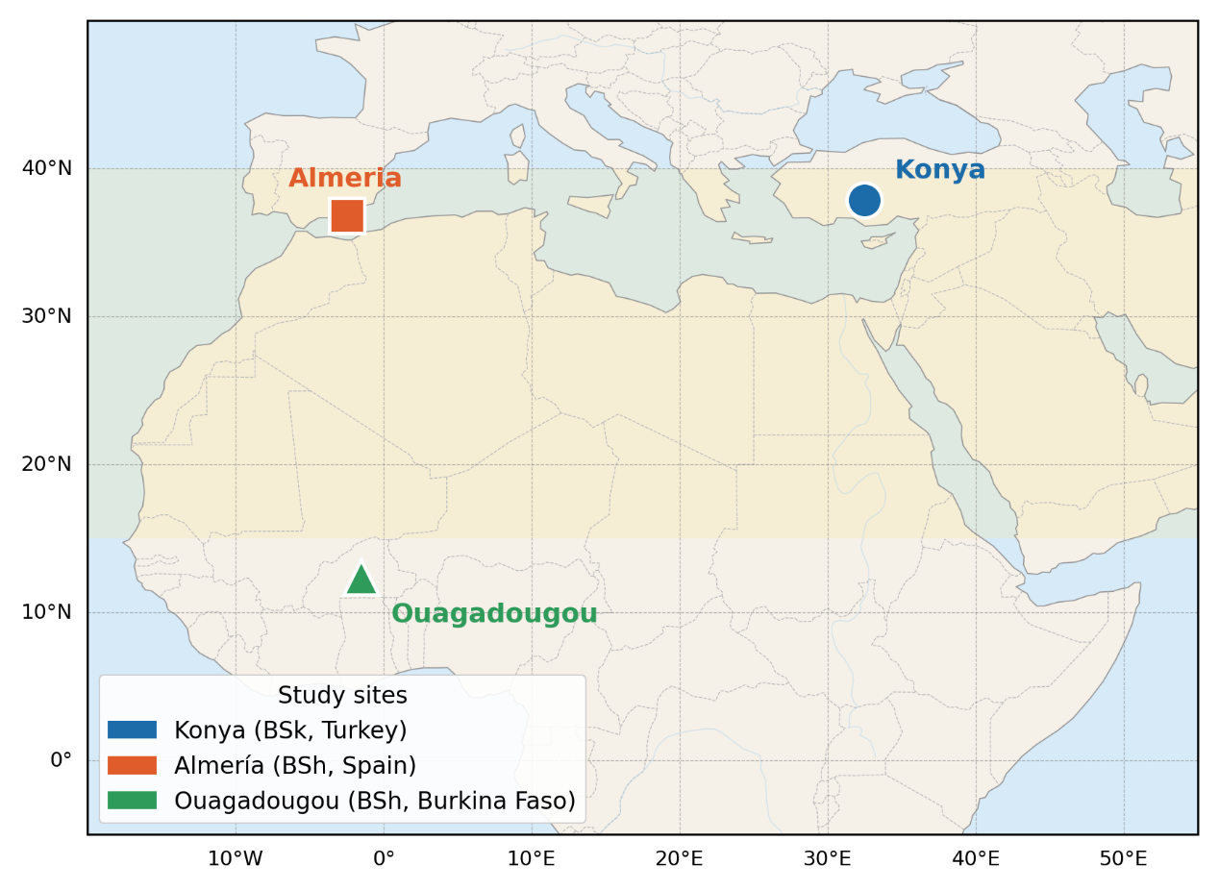
Figure 1 : Location map of the three study sites (Konya, Turkey; Almería, Spain; Ouagadougou, Burkina Faso) overlaid on the semi-arid belt of Europe, the Middle East and West Africa (BSk/BSh zones shaded in light yellow)
Their principal geographical and climatic characteristics are summarized in Table 4.

Table 4 : Geographical and climatic characteristics of the three study sites (mean values from PVGIS-SARAH2 TMY data) (JRC Photovoltaic Geographical Information System (PVGIS) - European Commission, n.d.).
Parameter | Konya (Turkey) | Almería (Spain) | Ouagadougou (Burkina Faso)
Latitude | 37.87° N | 36.83° N | 12.37° N
Longitude | 32.49° E | 2.46° W | 1.52° W
Elevation (m a.s.l.) | 1,016 | 20 | 303
Köppen climate | BSk (cold semi-arid) | BSh (hot semi-arid) | BSh (tropical semi-arid)
Mean annual GHI (kWh/m²) | 1,650 | 1,850 | 2,050
Mean annual T (°C) | 11.5 | 18.5 | 28.5
Summer $T_{max}\left(°C\right)$ | 38 | 35 | 41
Winter $T_{min}\left(°C\right)$ | -10 | 5 | 15
Annual ET₀ (mm) | 1,200 | 1,350 | 1,800
Annual precipitation (mm) | 320 | 200 | 800
Irrigation requirement (mm) | 880 | 1,150 | 1,000

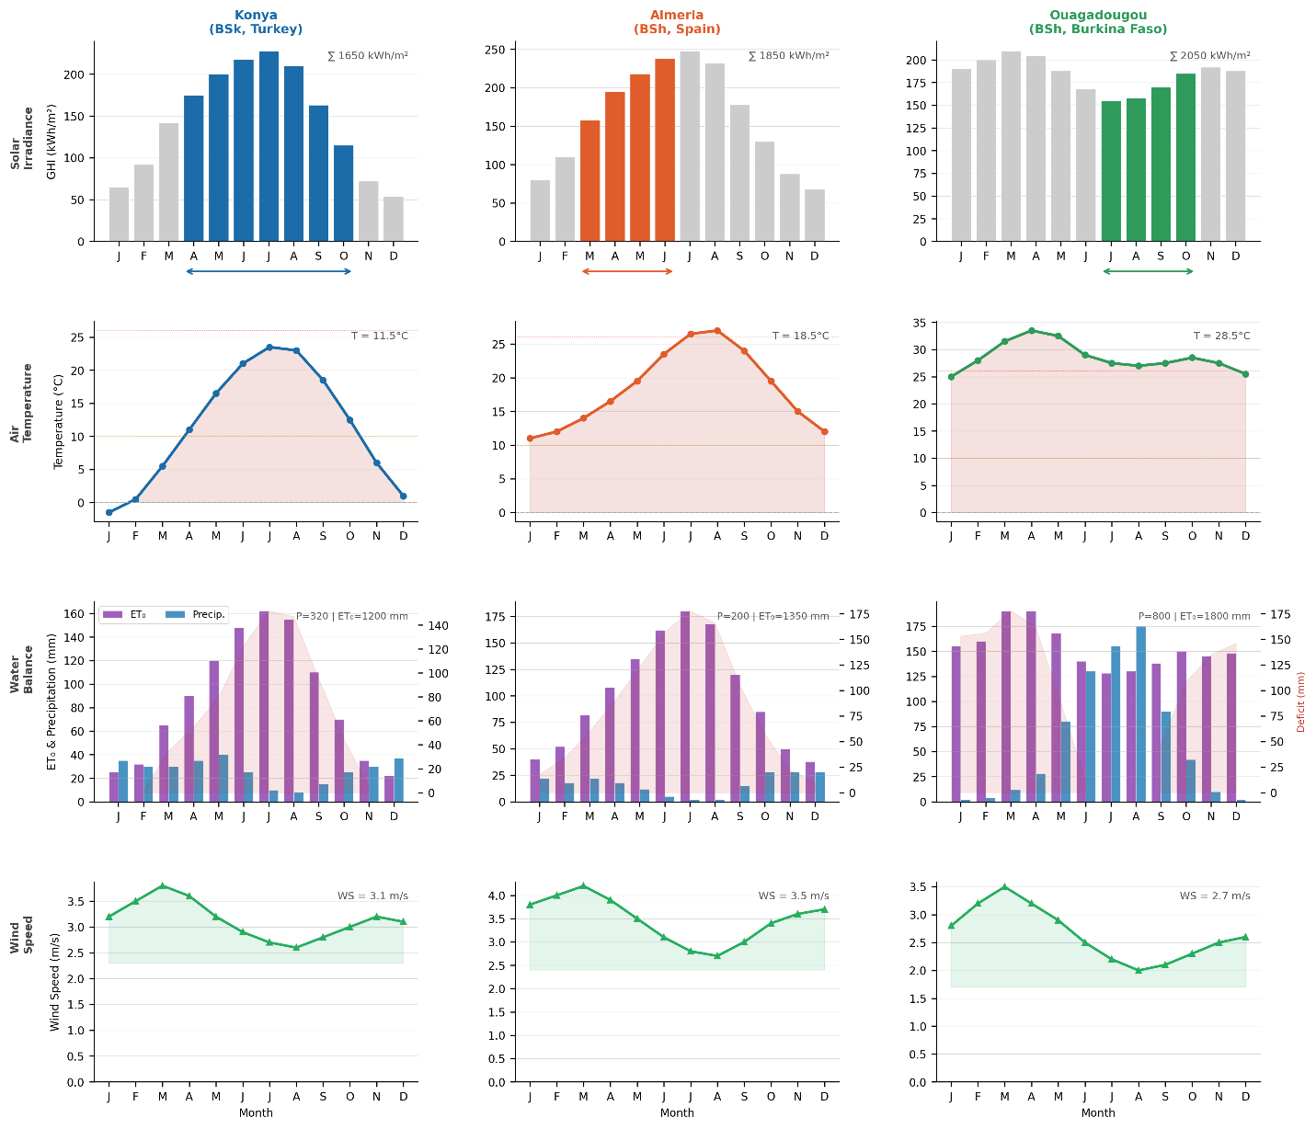
Figure 2 : Monthly climate profiles for the three sites: (a) GHI (kWh/m²), (b) mean air temperature (°C), (c) ET₀ vs precipitation (mm), and (d) wind speed (m/s). Horizontal bars indicate the tomato growing season.

Konya (37.87°N, 32.49°E, 1,016 m a.s.l.) is representative of the Central Anatolian Plateau, where a continental climate produces extreme seasonal swings: mean July temperatures around 23°C with maxima approaching 38°C give way to January means near −3°C with minima reaching −18°C or below (JRC Photovoltaic Geographical Information System (PVGIS) - European Commission, n.d.). Annual GHI is approximately 1,650 kWh/m², and the persistent summer water deficit — potential evapotranspiration exceeds precipitation every month from May through September — makes irrigation essential for any commercial crop production. These conditions simultaneously maximize the solar resource for the PV subsystem and present the most demanding thermal challenge for mesophilic anaerobic digestion, since winter ambient temperatures are far below the mesophilic optimum: this is precisely the regime where the PV-heat coupling proposed in this study has the greatest operational value.
Almería (36.83°N, 2.46°W, 22 m a.s.l.) sits on the Mediterranean coast of Andalusia and holds the distinction of being the driest location in continental Europe, with annual precipitation averaging just 200 mm against an ET₀ of 1,350 mm (Junta de Andalucía, 2022). The region hosts Europe's most intensively managed horticultural landscape, with over 30,000 hectares of plastic greenhouse cultivation making it one of the world's most studied agrivoltaic test environments (Marín-Membrive et al., 2021). Unlike Konya, winter temperatures in Almería rarely fall below 5°C, which eliminates the risk of digester freezing and substantially reduces the heating energy needed for mesophilic operation. The high summer irradiance (GHI peak months exceeding 200 kWh/m² (JRC Photovoltaic Geographical Information System (PVGIS) - European Commission, n.d.)) and mild winters also make this an ideal site for demonstrating the PV-heat synergy under the most favorable conditions.
Ouagadougou (12.37°N, 1.52°W, 303 m a.s.l.) lies in the Sahel and offers the highest solar resource of the three sites, with GHI averaging 2,050 kWh/m² annually — among the highest values encountered in any inhabited agricultural region globally (JRC Photovoltaic Geographical Information System (PVGIS) - European Commission, n.d.). The tropical semi-arid climate has a strongly seasonal character: approximately 800 mm of rainfall is concentrated in the June–September monsoon, followed by a long dry season during which temperatures can exceed 40°C. Mean annual temperature is 28.5°C, with winter minima remaining above 13°C, meaning that the digester operates near the mesophilic optimum for most of the year with minimal heating demand. Acute water scarcity during the dry season, when surface soils lose moisture rapidly, makes the evapotranspiration reduction and soil water retention benefits of an APV system particularly valuable for smallholder farmers.

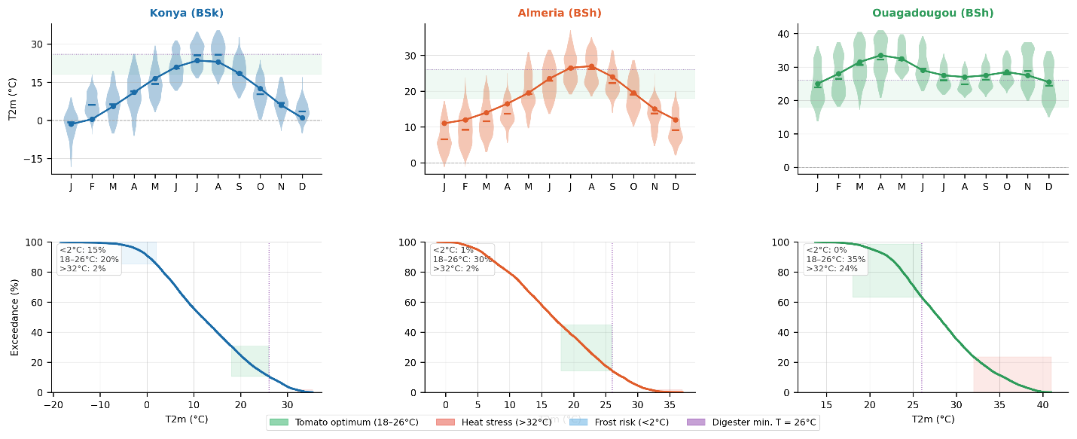
Figure 3 : Temperature characterization: (left) monthly distribution of 2‑m air temperature; (right) exceedance frequency curve. Colored bands indicate agronomic thresholds (optimal, heat stress, frost) and the minimum digester temperature (26 °C).

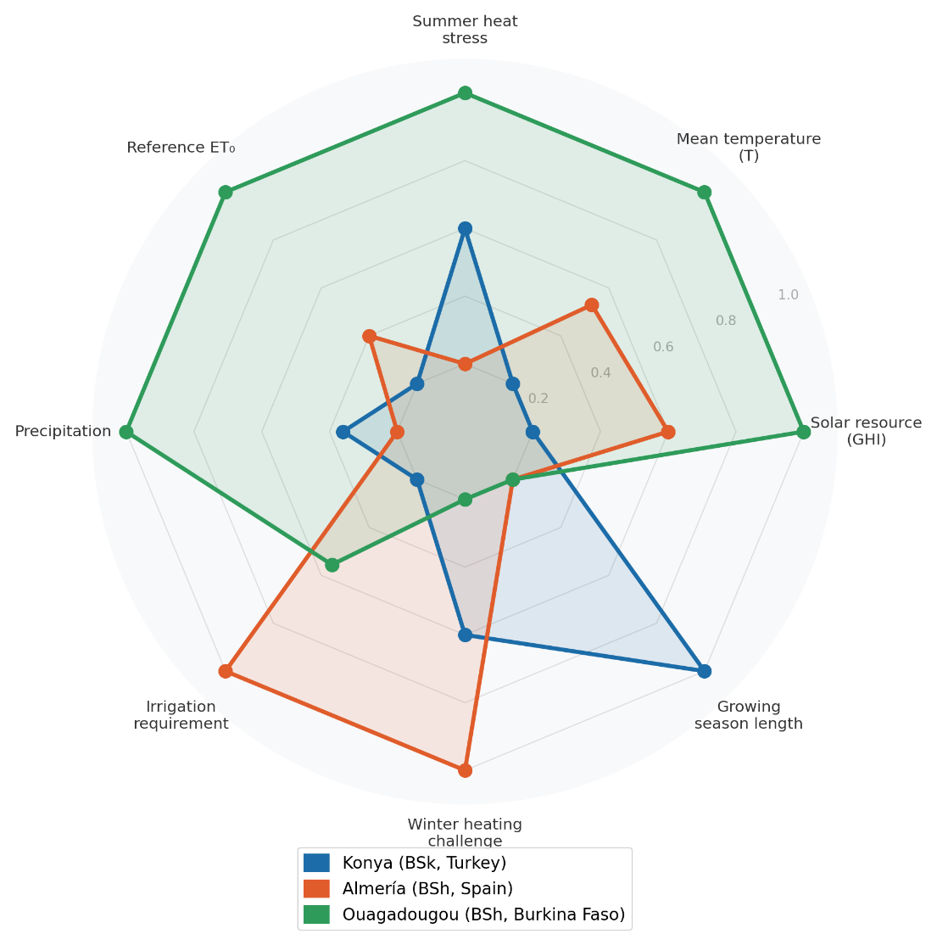
Figure 4 : Normalized radar chart comparing the three sites across eight climatic and agricultural dimensions (outer = higher value). This highlights the trade‑offs between solar resource, temperature extremes, water balance and growing season length.
3.2. Climate data acquisition and processing
Hourly meteorological data for all three sites were extracted from the PVGIS-SARAH3 Typical Meteorological Year (TMY) database maintained by the Joint Research Centre of the European Commission. Each TMY file provides 8,760 hourly records covering nine variables: global horizontal irradiance G(h) [W/m²], direct normal irradiance Gb(n) [W/m²], diffuse horizontal irradiance Gd(h) [W/m²], 2-m air temperature T2m [°C], relative humidity RH [%], 10-m wind speed WS10m [m/s], wind direction [°], and surface pressure SP [Pa] (JRC Photovoltaic Geographical Information System (PVGIS) - European Commission, n.d.).
PVGIS-SARAH3 was selected over ERA5 reanalysis because its solar irradiance fields are derived from Meteosat Second Generation (MSG) satellite observations rather than numerical weather prediction, yielding substantially lower hourly GHI bias for the Mediterranean basin, the Anatolian Plateau, and the West African Sahel — the three regions relevant to this study (Huld et al., 2012) (Huld et al Urraca et al., 2017). Validation studies for North Africa and the Sahel have confirmed mean bias errors below ±5% for monthly GHI (Urraca et al., 2017), which is the relevant accuracy threshold for annual energy yield modelling.
The TMY files were processed to extract DNI and DHI columns directly, rather than estimating them from GHI using fixed beam-to-diffuse ratios — an improvement over simplified approaches that can introduce systematic errors under variable sky conditions. No data gaps exceeding one hour were encountered in any of the three downloaded files. Site-specific parameters for tomato cultivation — planting and harvest dates, crop ET coefficients, and economic assumptions — are summarized in Table 5.

Table 5 : Site-specific parameters for tomato cultivation (Solanum lycopersicum) used in the model.
Parameter | Konya | Almería | Ouagadougou
Planting date | 25 April | 1 March | 1 July
Harvest date | 30 October | 30 June | 30 October
Growing season (days) | 189 | 122 | 122
Reference crop ET₀ (mm/season) | 650 | 480 | 620
Irrigation efficiency | 0.75 | 0.85 | 0.70
Tomato price (USD/t) | 300 | 400 | 250
Electricity price (USD/kWh) | 0.06 | 0.09 | 0.12
Discount rate (%) | 8 | 6 | 10

The planting and harvest dates reflect realistic agronomic management at each site. The Konya season runs from late April to late October (189 days), exploiting the long continental summer while avoiding spring frost risk and autumn cold. The Almería season is deliberately truncated at the end of June to avoid the July–August peak heat period, when daily maxima exceeding 35°C suppress tomato fruit set and quality — consistent with the management practice in the region\'s open-field production systems (Marín-Membrive et al., 2021). In Ouagadougou, the season is timed to the wet monsoon (July–October), avoiding the extreme pre-monsoon heat period from March to May when daily maxima routinely exceed 40°C and tomato flowering is severely compromised; this calendar aligns with recommendations for dry-season tomato cultivation in the Sahel (Fertilizer Use by Crop, 2006)

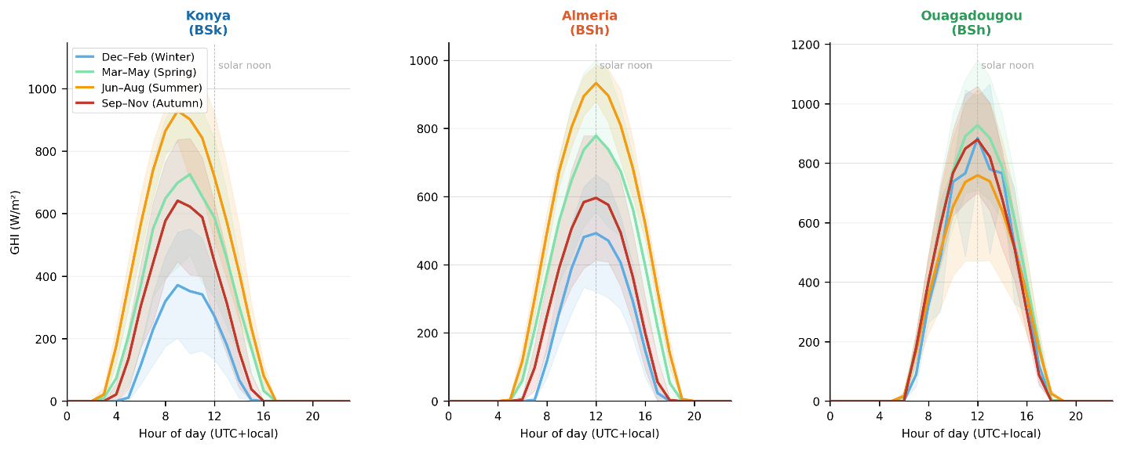
Figure 5 : Mean diurnal GHI profiles by season (DJF, MAM, JJA, SON) derived from PVGIS‑SARAH3 TMY data. Shaded bands represent ±1 standard deviation.

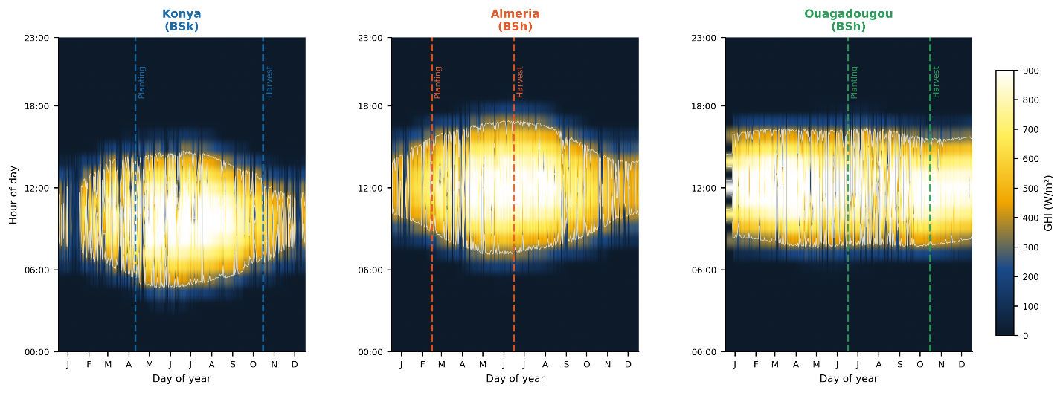
Figure 6 : Day‑of‑year × hour‑of‑day GHI heatmap (W/m²). White contour = 400 W/m² threshold; vertical dashed lines = start and end of the tomato growing season.
3.3. Solar geometry and shading model
Accurate hourly solar position calculation forms the foundation for both the PV transposition model and the ground shading factor. Solar declination δ is computed using the Spencer (1971) harmonic approximation:

$$\begin{aligned}δ=23.45°×sin\left[\frac{360°}{365}×\left(n-81\right)\right]\#\left(4\right)\end{aligned}$$

where n is the day of year. True solar time is obtained from local standard time by applying both a longitude correction for the offset from the standard meridian and the Equation of Time $EoT(n)$, which accounts for the eccentricity of Earth's orbit and the obliquity of the ecliptic (Spencer, 1971):

$$\begin{aligned}t_{solar}= t_{local}+\frac{\left(L - L_{std}\right)}{15} +\frac{EoT\left(n\right)}{60} \#\left(5\right)\end{aligned}$$

The solar hour angle ω follows directly, equaling zero at solar noon. Solar elevation angle $α_{s}$ and azimuth $γ_{s}$ are then computed from standard spherical trigonometric relations. The ground shading factor $F_{shad}\left(t\right)$, which quantifies the fraction of land area receiving direct shadow from the panel rows at each hour, is computed following Zainali et al. (Zainali et al., 2023), who validated this formulation against direct measurements across six agrivoltaic layouts:

$$\begin{aligned}F_{shad\left(t\right)}=\min\left(1,\frac{ H_{m}×\cos\left(Δγ\right)}{row_{spacing}×\tan\left(α_{s}\right)}\right)\#\left(6\right)\end{aligned}$$

where $H_{m}$ is the module bottom-edge height above ground in meters, $Δγ$ is the azimuth difference between the sun's direction and the row orientation, and $d_{row}$ is the row pitch in meters. The expression is clipped to a maximum of 1.0 to prevent non-physical values at very low solar elevation angles near sunrise and sunset.

3.4. Photovoltaic energy model
3.4.1. Plane-of-array irradiance
Unlike simplified approaches that apply a fixed beam-to-diffuse fraction to GHI, this study uses the direct DNI and DHI columns from the PVGIS-SARAH2 files. Plane-of-array irradiance is decomposed into three components following the isotropic sky model of Liu and Jordan (1960) (Liu & Jordan, n.d.):
$$\begin{aligned}G_{front}= DNI ×\cos\left(θ_{i}\right)+ DHI ×\frac{1 + cosβ}{2}+ GHI × ρ_{g}×\frac{1 - cosβ}{2}\#\left(7\right)\end{aligned}$$
where $θ_{i}$ is the angle of incidence on the tilted panel surface, $β$ is the tilt angle, and $ρ_{g}= 0.25$ is the ground albedo for agricultural soil (Monteith & Unsworth, 2008). For bifacial modules (Bifaciality factor $ϕ = 0.70$), the rear surface receives diffuse sky radiation on its underside plus ground-reflected radiation. The effective plane-of-array irradiance combining both sides is:

$$\begin{aligned}G_{eff}= G_{front}+ ϕ × G_{rear}× \left(1 - η_{loss}\right)\#\left(8\right)\end{aligned}$$

3.4.2. Cell temperature and power output
Cell operating temperature is modelled using the Faiman (2008) approach, which is more appropriate for dynamic hourly simulation than the Nominal Operating Cell Temperature (NOCT) method because it explicitly accounts for wind-dependent convective cooling:

$$\begin{aligned}T_{cell\left(t\right)}= T_{amb\left(t\right)}+\frac{G_{eff\left(t\right)}}{\left(U_{0}+ U_{1}× u\left(t\right)\right)} \#\left(9\right)\end{aligned}$$
where U₀ = 25 W/m²·K is the constant thermal loss coefficient and U₁ = 6.84 W·s/m³·K is the wind-dependent coefficient, both from Faiman (Faiman, 2008). Module power output $P_{PV}$ in watts at each timestep is then:

$$\begin{aligned}P_{PV\left(t\right)}= P_{STC}× N × \left(1-η_{loss}\right)×\left[1 + β_{p}\left(T_{cell\left(t\right)}- 25\right)\right]×\frac{G_{eff\left(t\right)}}{1000} \#\left(10\right)\end{aligned}$$

where $N$ is the number of modules, $P_{STC}= 550 W_{p}$ is the rated power under standard test conditions (Jinko Tiger Neo N-type bifacial datasheet), $η_{loss}= 0.12$ aggregates wiring, inverter, and mismatch losses consistent with field measurements from comparable bifacial utility-scale installations (Jordan & Kurtz, 2013), and $β_{p}= -0.0035 °C^{-1}$ is the temperature power coefficient from the module datasheet.

3.5. Crop yield model
Relative crop yield $\frac{Y_{crop}}{Y_{ref}}$ is estimated from the seasonal integral of photosynthetically active radiation (PAR) reaching the crop canopy under the APV panels, normalized to the corresponding open-field PAR integral. PAR is estimated as 48% of GHI following McCree (McCree, 1971) and the subsequent empirical calibration by Jacovides et al. (Jacovides et al., 2006), who confirmed that the PAR/GHI ratio for agricultural sites under mixed sky conditions falls in the range 0.45–0.50, with 0.48 as the central estimate.
A crop-specific PAR saturation threshold is applied: when incident PAR exceeds the light saturation point, additional photons produce no incremental photosynthesis. For tomato (Solanum lycopersicum), the light saturation point is approximately 800 μmol/m²/s ≈ 174 W/m² (Mohammedi et al., 2023; Heuvelink, 2005), which is substantially higher than the 76 W/m² appropriate for shade-tolerant species such as lettuce or spinach. Using the correct species-specific threshold is methodologically critical: an erroneously low threshold inflates the simulated crop yield ratio to unity regardless of shading, masking the actual trade-off between panel coverage and crop productivity.
The hourly PAR integral over the growing season yields the annual yield ratio:

$$\begin{aligned}\frac{Y_{crop}}{Y_{ref}}=\frac{\int_{t_{0}}^{t_{1}}{\min\left(PAR_{AV}\left(t\right),PAR_{sat}\right)dt}}{\int_{t_{0}}^{t_{1}}{PAR_{open}\left(t\right)dt}}\#\left(11\right)\end{aligned}$$

where $PAR_{AV}\left(t\right)=GHI(t)×0.48×(1-F_{shad}(t)$ is the PAR reaching the crop canopy under panels, $PAR_{open}\left(t\right)=GHI\left(t\right)×0.48$ is open-field PAR, $PAR_{sat}=174 W/m^{2}$ is the tomato-specific saturation threshold $F_{shad}\left(t\right)$is the hourly shading factor (Eq. 6), and $t_{0}$and $t_{1}$ are the site-specific season start and end dates from Table 5.

Table 6 : Summarizes the growing season boundaries at each site along with the primary climatic constraint that determines them.
Parameter | Konya (Turkey) | Almería (Spain) | Ouagadougou (Burkina Faso)
Growing season start $\left(t_{0}\right)$ | 25 April | 1 March | 1 July
Growing season end $\left(t_{1}\right)$ | 30 October | 30 June | 30 October
Season duration (days) | 189 | 122 | 122
Primary climatic constraint | Spring frost risk | Summer heat stress | Pre-monsoon heat (March–May)

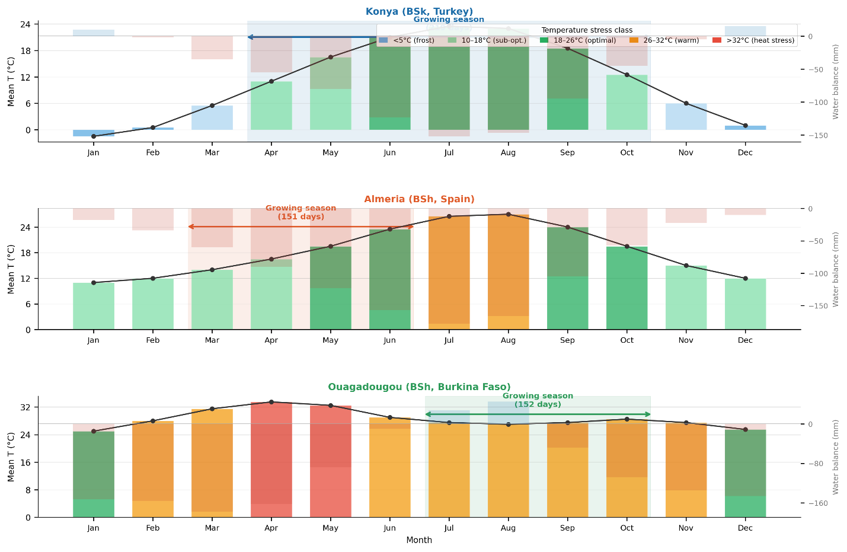
Figure 7 : Growing season calendar, monthly mean temperature colored by stress class, and water balance (deficit/surplus). The benefit of APV shading during heat‑stress periods is indicated.

3.6. Evapotranspiration reduction under APV panels
One of the most agriculturally significant benefits of agrivoltaic systems in semi-arid regions is the reduction of crop evapotranspiration that results from panel shading, which directly translates into lower irrigation requirements. Field evidence from lysimeter experiments consistently confirms this effect (Elamri et al., 2018; Mohammedi et al., 2023; Semeraro et al., 2024). Reference evapotranspiration ET₀ is calculated hourly using the FAO-56 Penman-Monteith equation (Allen et al., n.d.):

$$\begin{aligned}ET_{0}=\frac{0.408δ\left(R_{n}-G\right)+ γ\left(\frac{C_{n}}{T+273}\right)u_{2}\left(e_{s}-e_{a}\right)}{δ + γ\left(1+C_{d}·u^{2}\right)}\#\left(12\right)\end{aligned}$$

where $δ$ is the slope of the saturation vapor pressure curve (kPa/°C), $γ$ is the psychrometric constant (0.0665 kPa/°C at Konya elevation, adjusted for Almería and Ouagadougou), $R_{n}$ is net radiation (MJ/m²/h), $G$ is soil heat flux (neglected at hourly scale following (Allen et al., n.d.)), u₂ is wind speed at 2 m height (corrected from 10 m using a logarithmic profile with roughness length $z_{0}= 0.03 m$), $(e_{s} - e_{a})$ is vapor pressure deficit, and $C_{n}= 37$ and $C_{d}= 0.24$ are hourly daytime coefficients.
APV panels intercept incoming solar radiation and thereby reduce the net radiation term $R_{n}$ that drives evaporation. This shading correction is captured as:

$$\begin{aligned}R_{n,APV}\left(t\right)= R_{n,open}\left(t\right)× \left(1 - F_{shad\left(t\right)}\right)\#\left(13\right)\end{aligned}$$

In practice, the full Penman-Monteith calculation with the modified $R_{n}$ is linearized around the shading fraction to give:

$$\begin{aligned}ET_{APV}\left(t\right)= ET_{0}\left(t\right)× \left(1 - α_{shade}× F_{shad}\left(t\right)\right)\#\left(14\right)\end{aligned}$$

where $α_{shade}= 0.40$ is an empirically calibrated shading efficiency coefficient representing the fraction of ET reduction per unit shading fraction. This value lies within the 0.30–0.50 range established from lysimeter measurements at APV sites in semi-arid Mediterranean and continental climates (Elamri et al., 2018; Hassanpour Adeh et al., 2018) (Tawassulli, 2025; Elamri et al., 2018; Hassanpour Adeh et al., 2018). Annual water savings $W_{saved}$ are then:

$$\begin{aligned}W_{saved}= \sum_{t}{\left[ET_{0}\left(t\right)- ET_{APV\left(t\right)}\right]}\#\left(15\right)\end{aligned}$$

computed over the growing season only to ensure comparability with the crop yield calculation.

3.7. Anaerobic digestion model
3.7.1. Feedstock characterization
The AD subsystem is fed exclusively with the tomato crop residues generated on the same hectare as the agrivoltaic installation. With a fresh fruit yield of 60 t/ha and a residue-to-fruit mass ratio of 0.80 (Lallement et al., 2023; Mohammedi et al., 2023), annual fresh residue availability is 48 t/ha. Standard proximate analysis characterizes the residue as having a dry matter fraction DM = 0.20 kg DM/kg fresh and a volatile solids fraction VS = 0.85 kg VS/kg DM, yielding total volatile solids input of 8,160 kg VS/ha per season. The reference biochemical methane potential at 37°C is $BMP_{ref} = 300 NmL CH₄/g VS$, the well-documented central estimate for tomato residue mixtures with branches below 20% (Feng et al., 2013; Lallement et al., 2023).

3.7.2. Temperature-corrected methane yield
Biogas yield is sensitive to temperature, which is particularly important at Konya where winter ambient temperatures regularly fall below 0°C and effective digester temperature can drop significantly below the mesophilic optimum. Effective digester temperature $T_{dig,eff}$ follows a seasonal management strategy informed by Lindorfer et al. (Lindorfer et al., 2008): the digester is actively heated to a minimum of 26°C in winter and spring, and allowed to approach the mesophilic optimum of 37°C in summer and autumn when solar energy is abundant:

$$\begin{aligned}T_{dig,eff}= clip\left(T_{amb}+ 5, 26°C, 37°C\right)\#\left(16\right)\end{aligned}$$

The +15°C offset reflects the active heating capacity of the system under the assumed insulation standard ($U_{eff} = 0.8 W/m²·K$). The temperature-corrected BMP is then given by the Arrhenius relationship validated by Pilarski and Pilarska (Pilarski & Pilarska, 2025) and Lindorfer et al. (Lindorfer et al., 2008):

$$\begin{aligned}BMP\left(T_{dig,eff}\right)= BMP_{ref}×\exp\left[θ × \left(T_{dig,eff}- 37\right)\right]\#\left(17\right)\end{aligned}$$

where $θ = 0.069 °C⁻¹$. The monthly BMP correction is computed from monthly mean ambient temperatures drawn from the PVGIS-SARAH2 TMY dataset, introducing a physically grounded, site-specific coupling between the local climate and biogas subsystem performance.

3.7.3. Digester heat balance
Maintaining the reactor at $T_{dig,eff}$ requires a continuous heating energy supply. The daily heat demand $Q_{heat} (kWh/day)$ is computed from the energy balance of a cylindrical digester with height-to-diameter ratio H/D = 1:

$$\begin{aligned}Q_{heat}= Q_{loss,cond} + Q_{in flow}- Q_{reaction} \#\left(18\right)\end{aligned}$$

The conductive heat loss through the insulated reactor wall is:

$$\begin{aligned}Q_{loss,cond}= U_{eff}× A_{wall}× \left(T_{dig,eff}- T_{amb}\right)×\frac{24}{1000} \#\left(19\right)\end{aligned}$$

with $U_{eff} = 0.8 W/m²·K$, a value consistent with well-insulated farm-scale digesters equipped with 100 mm polyurethane foam insulation (Lindorfer et al., 2008; Pal & Ilango, 2024). The heat required to bring the incoming feedstock slurry from ambient temperature to the digester setpoint is:

$$\begin{aligned}Q_{inflow}= ṁ_{substrate}× C_{p}×\max\left(0, T_{dig,eff}- T_{amb}\right)/3600 \#\left(20\right)\end{aligned}$$

where $C_{p} = 4.18 kJ/kg·K$ is the specific heat capacity of dilute slurry (approximated as water). The exothermic biological reactions within the digester return a small fraction of heat to the system; following Pal and Ilango (Pal & Ilango, 2024), this is estimated as approximately 5% of the daily biogas energy:

$$\begin{aligned}Q_{reaction}= 0.05 × Ṁ_{CH_{4},daily}× LHV_{CH_{4}}\#\left(21\right)\end{aligned}$$

The PV system supplies a fraction $f_{PV,heat}$ of its annual generation as electrical resistance heating ($efficiency η_{elec}= 0.95$). Any remaining heat deficit is met by biogas combustion in a combined heat and power (CHP) unit ($η_{bio}= 0.85$). If biogas is insufficient to cover the deficit, the configuration is declared infeasible and excluded from the optimizer.

3.8. Extended Land Equivalent Ratio formulation
The classical two-component LER captures crop and PV outputs but entirely ignores the biogas energy recovered from the same hectare\'s residue stream. This study proposes an extended three-component LER (eLER) that incorporates net biogas as a third output:

$$\begin{aligned}eLER =\frac{Y_{crop,AV}}{Y_{crop,open}}+\frac{E_{PV,net}}{E_{PV,ref}}+\frac{E_{biogas,net}}{E_{biogas,ref}}\#\left(22\right)\end{aligned}$$

Each component is defined precisely. The crop component $\frac{Y_{crop,AV}}{Y_{crop,open}}$ is the relative yield ratio derived from the seasonal PAR integral (Eq. 11), with $Y_{crop,AV}$representing open-field tomato production at the same site with the same agronomic management. The PV component $\frac{E_{PV,net}}{E_{PV,ref}}$ uses $E_{PV,net}$ — annual PV electricity sold to the grid after deducting the heating allocation — in the numerator, and $E_{PV,ref}$ in the denominator, where the reference is computed from an independent open-field dense-pack simulation using the same module specifications at maximum GCR and the same tilt angle. This decoupled reference avoids the circular definition used in several prior studies, which derive the reference from the APV output itself. The biogas component $\frac{E_{biogas,net}}{E_{biogas,ref}}$ uses the net exported biogas energy (after self-heating) in the numerator, and the maximum methane energy recoverable from all residues in a thermally unconstrained AD unit at 37°C as the reference.
$eLER > 1$ indicates that the integrated APV-AD system produces more combined useful output per unit land area than the best-performing monoculture reference for each component in isolation. To enable direct comparison with the two-component LER values widely reported in the agrivoltaic literature, the crop and PV components of eLER are also reported separately as $LER_{2C}= LER_{crop}+ LER_{PV}$.
The three-component structure is an extension of the original Mead and Willey (Mead & Willey, 1980) intercropping LER framework, in which additional outputs can be incorporated as additional ratio terms (Trommsdorff, n.d.). Each component is dimensionless and represents a fractional land-use efficiency; their sum reflects the hypothetical number of hectares of specialized monocultures that would be needed to replicate all outputs of one hectare of the integrated system.

3.9. Multi-variable design optimization
The integrated system is optimized over six continuous design variables using differential evolution (DE), a gradient-free, population-based global optimizer that is well suited to non-convex, mixed-physics objective landscapes without gradient information (Storn, n.d.) (Storn & Price, 1997). The objective is to maximize $eLER_{global}$:
$$maximize eLER(x) subject to: 45 ≤ HRT ≤ 80 d, 1.5 ≤ OLR ≤ 4.0 kg VS/m³·d$$
The HRT bounds (45–80 days) reflect the requirements of lignocellulosic tomato residues, which hydrolyze more slowly than manure-based feedstocks and require longer retention times to achieve acceptable conversion efficiency (Pilarski & Pilarska, 2025). The OLR bounds follow published operating guidelines for mixed crop residue digesters (Wang et al., 2018). Table 7 summarizes the six design variables and their search bounds.

Table 7 : Design variable bounds for the differential evolution optimization. Bounds are based on physical constraints and published operational guidelines.
Variable | Symbol | Lower bound | Upper bound | Unit
Panel tilt angle | $$β$$ | 10 | 40 | °
Row spacing | $$d_{row}$$ | 4 | 14 | m
Module bottom-edge height | $$H_{m}$$ | 2 | 5 | m
Digester volume | $$V_{dig}$$ | 50 | 300 | m³
Hydraulic retention time | $$HRT$$ | 20 | 40 | days
PV heating fraction | $$f_{PV,heat}$$ | 0.05 | 0.50 | [-]

The DE algorithm uses a population size of $15 × n_{var}= 90$, a mutation factor $F ∈ [0.5, 1.0]$, and a crossover probability $C_{r}= 0.7$. A maximum of 50 generations is specified, after which the best candidate is polished with the L-BFGS-B local optimizer. Configurations violating the HRT or OLR constraints, or for which biogas is insufficient to sustain digester temperature, receive a penalty of eLER = 0, effectively excluding them from the feasible region. The algorithm is seeded (seed = 42) for full reproducibility. A minimum crop yield constraint of 80% of open-field yield is applied as a soft penalty in the objective function, reflecting the agronomic requirement that any commercially viable agrivoltaic configuration must maintain most of the baseline crop revenue.

3.10. Summary of model parameters
All fixed model parameters, their values, units, and bibliographic sources are compiled in Table 8. This table serves as the single reference point for model reproducibility.

Table 8 : Fixed model parameters used in the simulation, with values, units, and primary sources.
Parameter | Symbol | Value | Unit | Source
Module rated power | $$P_{STC}$$ | 550 | $$W_{p}$$ | Jinko Tiger Neo datasheet
Bifaciality factor | $$ϕ$$ | 0.70 | − | Jinko Tiger Neo datasheet
Temperature coefficient | $$β_{p}$$ | −0.0035 | K⁻¹ | Jinko Tiger Neo datasheet
System losses | $$η_{loss}$$ | 0.12 | − | (Jordan & Kurtz, 2013)
Faiman U₀ | U₀ | 25 | W/m²·K | (Faiman, 2008)
Faiman U₁ | U₁ | 6.84 | W·s/m³·K | (Faiman, 2008)
Ground albedo | $$ρ_{g}$$ | 0.25 | − | (Monteith & Unsworth, 2008)
PAR fraction of GHI | $$f_{PAR}$$ | 0.48 | − | (Jacovides et al., 2006; McCree, 1971)
Tomato PAR saturation | $$PAR_{sat}$$ | 174 | W/m² | (Mohammedi et al., 2023)  Heuvelink (2005)
ET shading coefficient | $$α_{shade}$$ | 0.40 | − | Tawassulli 2025
'Tomato dry matter fraction | $$DM$$ | 0.20 | kg/kg fresh | (Mohammedi et al., 2023)
Volatile solids fraction | $$VS$$ | 0.85 | kg VS/kg DM | (Lallement et al., 2023)
'Reference BMP at 37°C | $$BMP_{ref}$$ | 300 | NmL/g VS | (Lallement et al., 2023)
Arrhenius coefficient | $$θ$$ | 0.069 | °C⁻¹ | (Lindorfer et al., 2008; Pilarski & Pilarska, 2025)
Digester thermal transmittance | $$U_{eff}$$ | 0.8 | W/m²·K | (Lindorfer et al., 2008; Pal & Ilango, 2024)
Substrate heat capacity | $$C_{p}$$ | 4.18 | kJ/kg·K | Water approximation (dilute slurry)
Electrical heating eff. | $$η_{elec}$$ | 0.95 | − | (Pal & Ilango, 2024)
Biogas CHP heating eff. | $$η_{bio}$$ | 0.85 | − | (Temiz et al., n.d.)
Methane LHV | $$LHV_{CH_{4}}$$ | 35.8 | MJ/m³ | (Marchaim, 1992)
Fruit yield (tomato) | $$Y_{fruit}$$ | 60 | t/ha | (Mohammedi et al., 2023)
Residue/fruit ratio | $$R_{res}$$ | 0.80 | − | (Mohammedi et al., 2023)

body('Heuvelink, E. (2005). Tomatoes. CABI Publishing.'),
body('JRC/EC (2023). PVGIS-SARAH2 photovoltaic geographical information system. European Commission Joint Research Centre. https://re.jrc.ec.europa.eu/pvg_tools/'),
body('Junta de Andalucía (2022). Anuario de estadísticas agrarias y pesqueras. Consejería de Agricultura, Pesca, Agua y Desarrollo Rural.'),
body('Marín-Membrive, P., López-Marín, J., González, A., & García-Alonso, Y. (2021). Agrivoltaic systems in Almería, Spain: Actual state and future perspectives. Agronomy, 11(4), 593.'),

Allen, R. G., Pereira, L. S., Raes, D., & Smith, M. (n.d.). Crop evapotranspiration—Guidelines for computing crop water requirements—FAO Irrigation and drainage paper 56.
Amaducci, S., Yin, X., & Colauzzi, M. (2018). Agrivoltaic systems to optimise land use for electric energy production. Applied Energy, 220, 545–561. https://doi.org/10.1016/j.apenergy.2018.03.081
Angelidaki, I., Alves, M., Bolzonella, D., Borzacconi, L., Campos, J. L., Guwy, A. J., Kalyuzhnyi, S., Jenicek, P., & Van Lier, J. B. (2009). Defining the biomethane potential (BMP) of solid organic wastes and energy crops: A proposed protocol for batch assays. Water Science and Technology, 59(5), 927–934. https://doi.org/10.2166/wst.2009.040
Barron-Gafford, G. A., Pavao-Zuckerman, M. A., Minor, R. L., Sutter, L. F., Barnett-Moreno, I., Blackett, D. T., Thompson, M., Dimond, K., Gerlak, A. K., Nabhan, G. P., & Macknick, J. E. (2019). Agrivoltaics provide mutual benefits across the food–energy–water nexus in drylands. Nature Sustainability, 2(9), 848–855. https://doi.org/10.1038/s41893-019-0364-5
Chalgynbayeva, A., Gabnai, Z., Lengyel, P., Pestisha, A., & Bai, A. (2023). Worldwide Research Trends in Agrivoltaic Systems—A Bibliometric Review. Energies, 16(2), 611. https://doi.org/10.3390/en16020611
Dinesh, H., & Pearce, J. M. (2016). The potential of agrivoltaic systems. Renewable and Sustainable Energy Reviews, 54, 299–308. https://doi.org/10.1016/j.rser.2015.10.024
Dupraz, C., Marrou, H., Talbot, G., Dufour, L., Nogier, A., & Ferard, Y. (2011). Combining solar photovoltaic panels and food crops for optimising land use: Towards new agrivoltaic schemes. Renewable Energy, 36(10), 2725–2732. https://doi.org/10.1016/j.renene.2011.03.005
Elamri, Y., Cheviron, B., Lopez, J.-M., Dejean, C., & Belaud, G. (2018). Water budget and crop modelling for agrivoltaic systems: Application to irrigated lettuces. Agricultural Water Management, 208, 440–453. https://doi.org/10.1016/j.agwat.2018.07.001
Faiman, D. (2008). Assessing the outdoor operating temperature of photovoltaic modules. Progress in Photovoltaics: Research and Applications, 16(4), 307–315. https://doi.org/10.1002/pip.813
FAO. (2017). The future of food and agriculture: Trends and challenges. Food and Agriculture Organization of the United Nations.
Feng, L., Li, Y., Chen, C., Liu, X., Xiao, X., Ma, X., Zhang, R., He, Y., & Liu, G. (2013). Biochemical Methane Potential (BMP) of Vinegar Residue and the Influence of Feed to Inoculum Ratios on Biogas Production. BioResources, 8(2), 2487–2498. https://doi.org/10.15376/biores.8.2.2487-2498
Fertilizer use by crop. (2006). Food and Agriculture Organization of the United Nations.
Goetzberger, A., & Zastrow, A. (1982). On the Coexistence of Solar-Energy Conversion and Plant Cultivation. International Journal of Solar Energy, 1(1), 55–69. https://doi.org/10.1080/01425918208909875
Gorjian, S., Bousi, E., Özdemir, Ö. E., Trommsdorff, M., Kumar, N. M., Anand, A., Kant, K., & Chopra, S. S. (2022). Progress and challenges of crop production and electricity generation in agrivoltaic systems using semi-transparent photovoltaic technology. Renewable and Sustainable Energy Reviews, 158, 112126. https://doi.org/10.1016/j.rser.2022.112126
Hassanpour Adeh, E., Selker, J. S., & Higgins, C. W. (2018). Remarkable agrivoltaic influence on soil moisture, micrometeorology and water-use efficiency. PLOS ONE, 13(11), e0203256. https://doi.org/10.1371/journal.pone.0203256
Huld, T., Müller, R., & Gambardella, A. (2012). A new solar radiation database for estimating PV performance in Europe and Africa. Solar Energy, 86(6), 1803–1815. https://doi.org/10.1016/j.solener.2012.03.006
Imran, H., Riaz, M. H., & Butt, N. Z. (2020). Optimization of Single-Axis Tracking of Photovoltaic Modules for Agrivoltaic Systems. 2020 47th IEEE Photovoltaic Specialists Conference (PVSC), 1353–1356. https://doi.org/10.1109/PVSC45281.2020.9300682
Jacovides, C. P., Tymvios, F. S., Assimakopoulos, V. D., & Kaltsounides, N. A. (2006). Comparative study of various correlations in estimating hourly diffuse fraction of global solar radiation. Renewable Energy, 31(15), 2492–2504. https://doi.org/10.1016/j.renene.2005.11.009
Jordan, D. C., & Kurtz, S. R. (2013). Photovoltaic Degradation Rates—An Analytical Review. Progress in Photovoltaics: Research and Applications, 21(1), 12–29. https://doi.org/10.1002/pip.1182
JRC Photovoltaic Geographical Information System (PVGIS)—European Commission. (n.d.). Retrieved April 10, 2026, from https://re.jrc.ec.europa.eu/pvg_tools/en/
Lallement, A., Peyrelasse, C., Lagnet, C., Barakat, A., Schraauwers, B., Maunas, S., & Monlau, F. (2023). A Detailed Database of the Chemical Properties and Methane Potential of Biomasses Covering a Large Range of Common Agricultural Biogas Plant Feedstocks. Waste, 1(1), 195–227. https://doi.org/10.3390/waste1010014
Lindorfer, H., Waltenberger, R., Köllner, K., Braun, R., & Kirchmayr, R. (2008). New data on temperature optimum and temperature changes in energy crop digesters. Bioresource Technology, 99(15), 7011–7019. https://doi.org/10.1016/j.biortech.2008.01.034
Liu, B. Y. H., & Jordan, R. C. (n.d.). Characteristic Distribution Total Solar Radiation.
Macknick, J., Hartmann, H., Barron-Gafford, G., Beatty, B., Burton, R., Seok-Choi, C., Davis, M., Davis, R., Figueroa, J., Garrett, A., Hain, L., Herbert, S., Janski, J., Kinzer, A., Knapp, A., Lehan, M., Losey, J., Marley, J., MacDonald, J., … Walston, L. (2022). The 5 Cs of Agrivoltaic Success Factors in the United States: Lessons from the InSPIRE Research Study (NREL/TP-6A20-83566, 1882930, MainId:84339; p. NREL/TP-6A20-83566, 1882930, MainId:84339). https://doi.org/10.2172/1882930
Marchaim, U. (1992). Biogas processes for sustainable development. Food and Agriculture Organization of the United Nations.
Marrou, H., Guilioni, L., Dufour, L., Dupraz, C., & Wery, J. (2013). Microclimate under agrivoltaic systems: Is crop growth rate affected in the partial shade of solar panels? Agricultural and Forest Meteorology, 177, 117–132. https://doi.org/10.1016/j.agrformet.2013.04.012
Mazzeo, D., Di Zio, A., Pesenti, C., & Leva, S. (2025). Optimizing Agrivoltaic Systems: A Comprehensive Analysis of Design, Crop Productivity and Energy Performance in Open-Field Configurations. SSRN. https://doi.org/10.2139/ssrn.5082169
McCree, K. J. (1971). The action spectrum, absorptance and quantum yield of photosynthesis in crop plants. Agricultural Meteorology, 9, 191–216. https://doi.org/10.1016/0002-1571(71)90022-7
Mead, R., & Willey, R. W. (1980). The Concept of a ‘Land Equivalent Ratio’ and Advantages in Yields from Intercropping. Experimental Agriculture, 16(3), 217–228. https://doi.org/10.1017/S0014479700010978
Mohammedi, S., Dragonetti, G., Admane, N., & Fouial, A. (2023). The Impact of Agrivoltaic Systems on Tomato Crop: A Case Study in Southern Italy. Processes, 11(12), 3370. https://doi.org/10.3390/pr11123370
Möller, K., & Müller, T. (2012). Effects of anaerobic digestion on digestate nutrient availability and crop growth: A review. Engineering in Life Sciences, 12(3), 242–257. https://doi.org/10.1002/elsc.201100085
Monteith, J. L., & Unsworth, M. H. (2008). Principles of environmental physics (3rd ed). Elsevier.
Pal, A., & Ilango, G. S. (2024). Design and techno-economic analysis of an off-grid integrated PV-biogas system with a constant temperature digester for a cost-effective rural application. Energy, 287, 129671. https://doi.org/10.1016/j.energy.2023.129671
Pilarski, K., & Pilarska, A. A. (2025). Kinetics and Energy Yield in Anaerobic Digestion: Effects of Substrate Composition and Fundamental Operating Conditions. Energies, 18(23), 6262. https://doi.org/10.3390/en18236262
Proctor, K., Murthy, G., & Higgins, C. (2020). Agrivoltaics Align with Green New Deal Goals While Supporting Investment in the US’ Rural Economy. Sustainability, 13(1), 137. https://doi.org/10.3390/su13010137
Ravilla, A., Shirkey, G., Chen, J., Jarchow, M., Stary, O., & Celik, I. (2024). Techno-economic and life cycle assessment of agrivoltaic system (AVS) designs. Science of The Total Environment, 912, 169274. https://doi.org/10.1016/j.scitotenv.2023.169274
Reasoner, M., & Ghosh, A. (2022). Agrivoltaic Engineering and Layout Optimization Approaches in the Transition to Renewable Energy Technologies: A Review. Challenges, 13(2), 43. https://doi.org/10.3390/challe13020043
Renewable power generation costs in 2022. (2022).
Riaz, M. H., Imran, H., Alam, H., Alam, M. A., & Butt, N. Z. (2022). Crop-Specific Optimization of Bifacial PV Arrays for Agrivoltaic Food-Energy Production: The Light-Productivity-Factor Approach. IEEE Journal of Photovoltaics, 12(2), 572–580. https://doi.org/10.1109/JPHOTOV.2021.3136158
Semeraro, T., Scarano, A., Curci, L. M., Leggieri, A., Lenucci, M., Basset, A., Santino, A., Piro, G., & De Caroli, M. (2024). Shading effects in agrivoltaic systems can make the difference in boosting food security in climate change. Applied Energy, 358, 122565. https://doi.org/10.1016/j.apenergy.2023.122565
Storn, R. (n.d.). Differential Evolution—A simple and efficient adaptive scheme for global optimization over continuous spaces.
Temiz, M., Sinbuathong, N., & Dincer, I. (n.d.). Development and assessment of a new agrivoltaic‐biogas energy system for sustainable communities.
Trommsdorff, M. (n.d.). Performance Indices for Parallel Agriculture and PV.
Waller, R., Kacira, M., Magadley, E., Teitel, M., & Yehia, I. (2021). Semi-Transparent Organic Photovoltaics Applied as Greenhouse Shade for Spring and Summer Tomato Production in Arid Climate. Agronomy, 11(6), 1152. https://doi.org/10.3390/agronomy11061152
Weselek, A., Ehmann, A., Zikeli, S., Lewandowski, I., Schindele, S., & Högy, P. (2019). Agrophotovoltaic systems: Applications, challenges, and opportunities. A review. Agronomy for Sustainable Development, 39(4), 35. https://doi.org/10.1007/s13593-019-0581-3
Zainali, S., Ma Lu, S., Stridh, B., Avelin, A., Amaducci, S., Colauzzi, M., & Campana, P. E. (2023). Direct and diffuse shading factors modelling for the most representative agrivoltaic system layouts. Applied Energy, 339, 120981. https://doi.org/10.1016/j.apenergy.2023.120981
Zwietering, M. H., Jongenburger, I., Rombouts, F. M., & Van ’T Riet, K. (1990). Modeling of the Bacterial Growth Curve. Applied and Environmental Microbiology, 56(6), 1875–1881. https://doi.org/10.1128/aem.56.6.1875-1881.1990

